WEB ASSIGNMENT

Q1-

const mongoose = require('mongoose');

async function main(){

    await mongoose.connect('mongodb://127.0.0.1:27017/test3');

}

main()

.then(()=>{console.log("Connected Succesfully");})

.catch((err)=>{console.error(err);});

const userSchema = new mongoose.Schema({

    name:String,

    Roll_no:String,

    age:Number,

});

const User = mongoose.model("User",userSchema); // Making the model or we can say making the collection and giving the template to the collection.

const user1=new User({  // Inserting one by one or making the document for the collection User.

    name: "SUNNY",

    Roll_no: "22cs2037",

    age: 20

});

const user2=new User({  // Inserting or making the document for the collection User.

    name: "SHIVAM",

    Roll_no: "22cs2023",

    age: 20

});

user1.save();

user2.save();

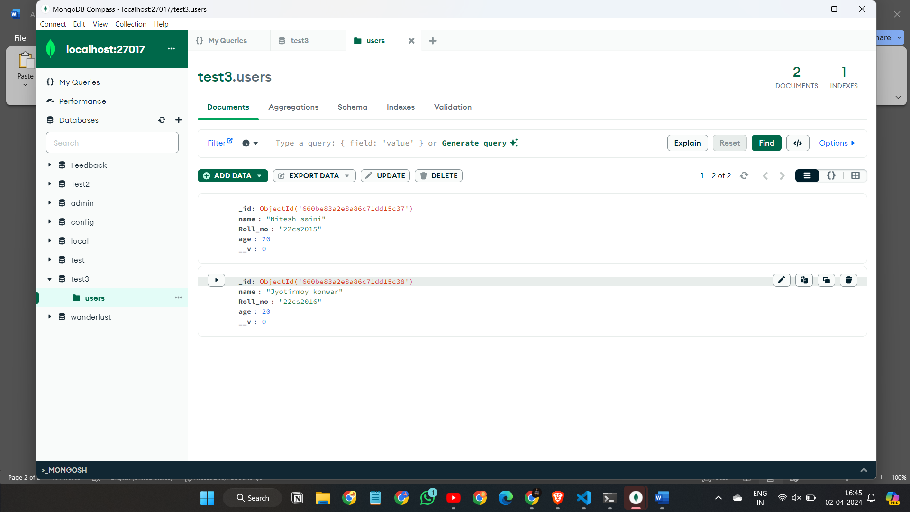

Q-2

Step -1

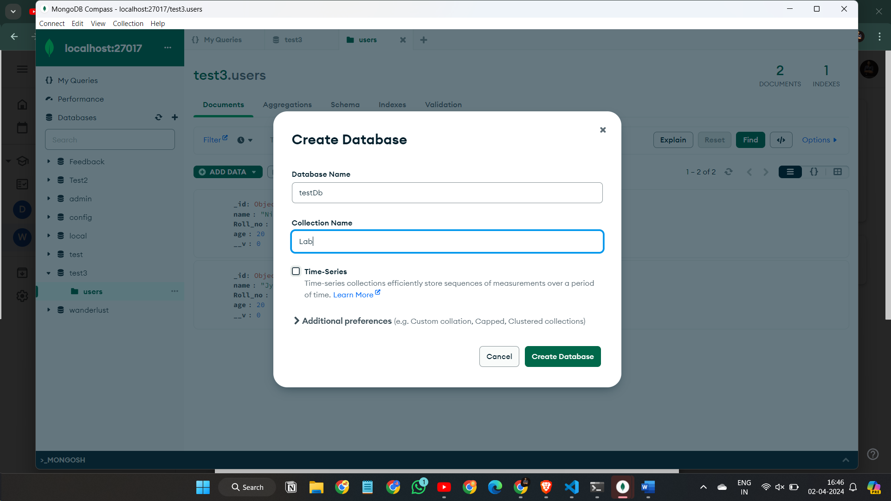

Step-2

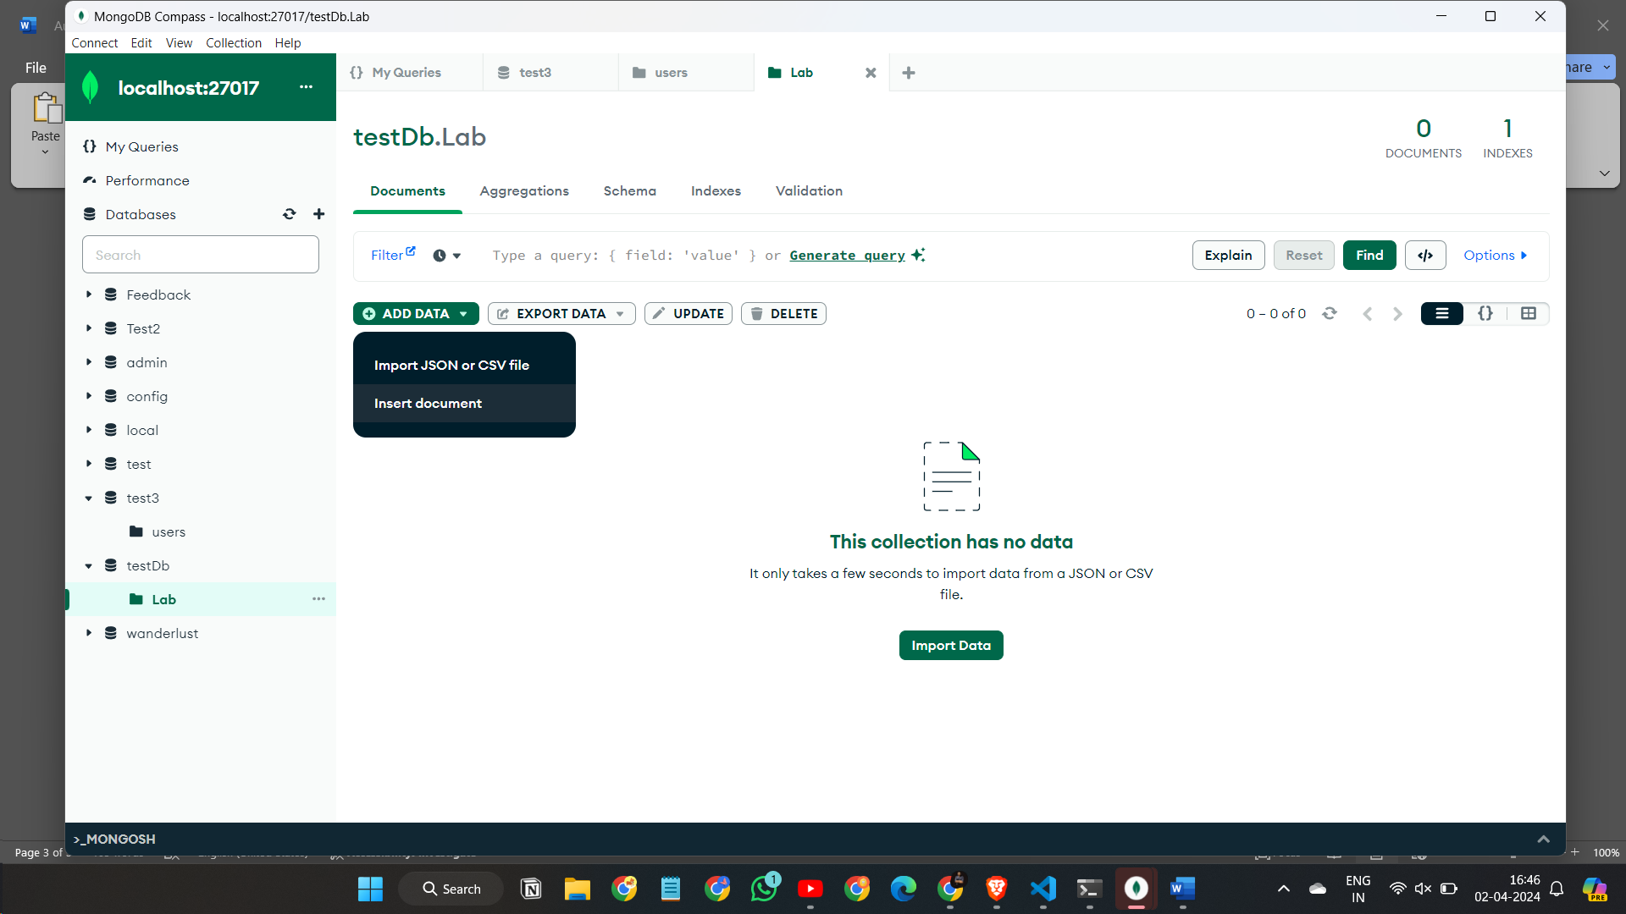

Step-3

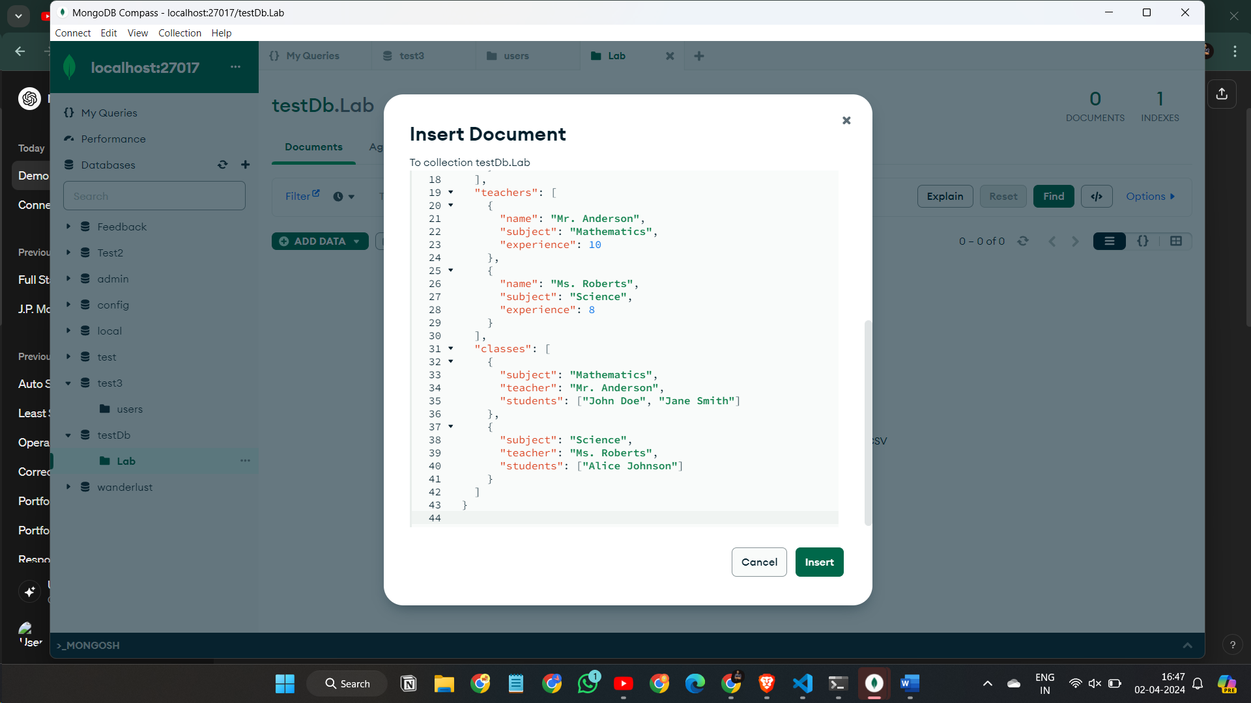

Step-4

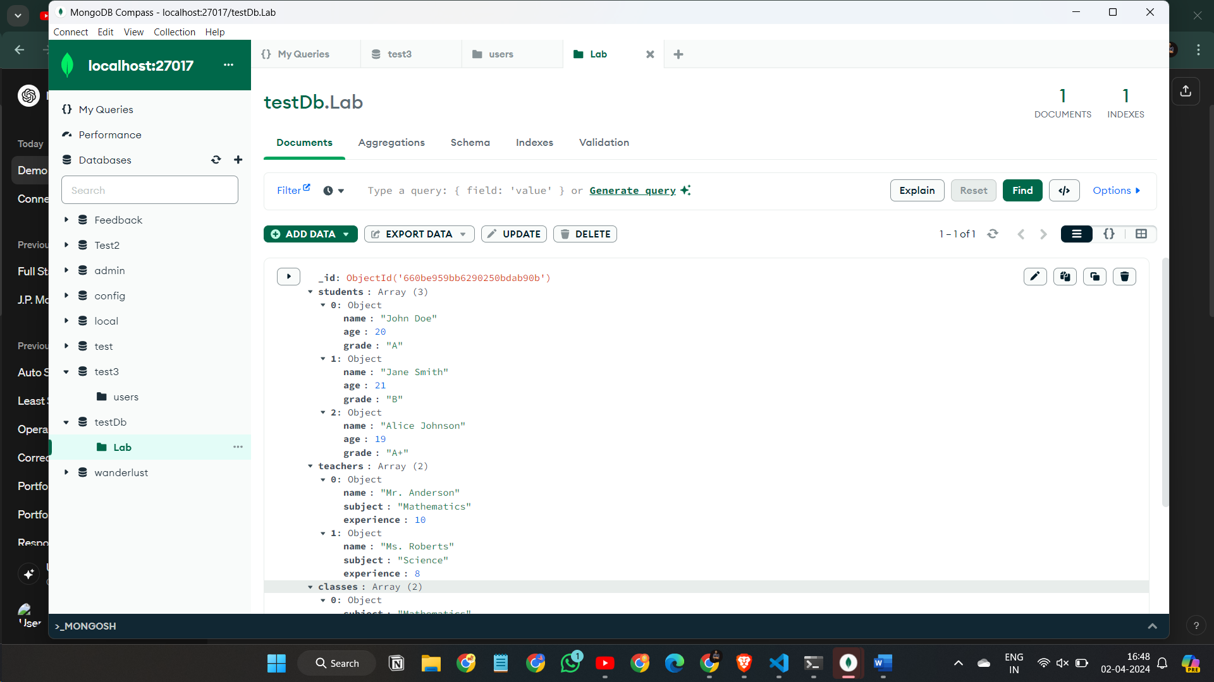

Q-3

Step-1

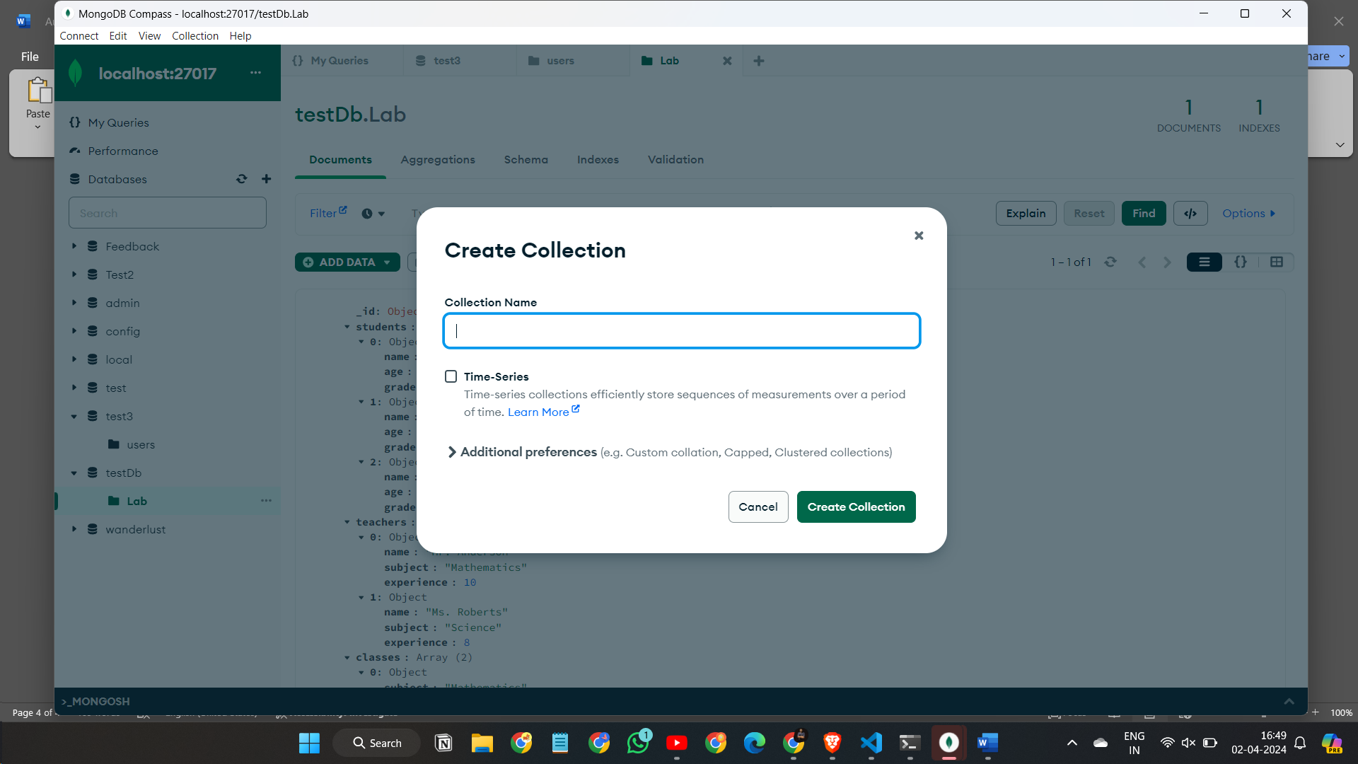

Step-2

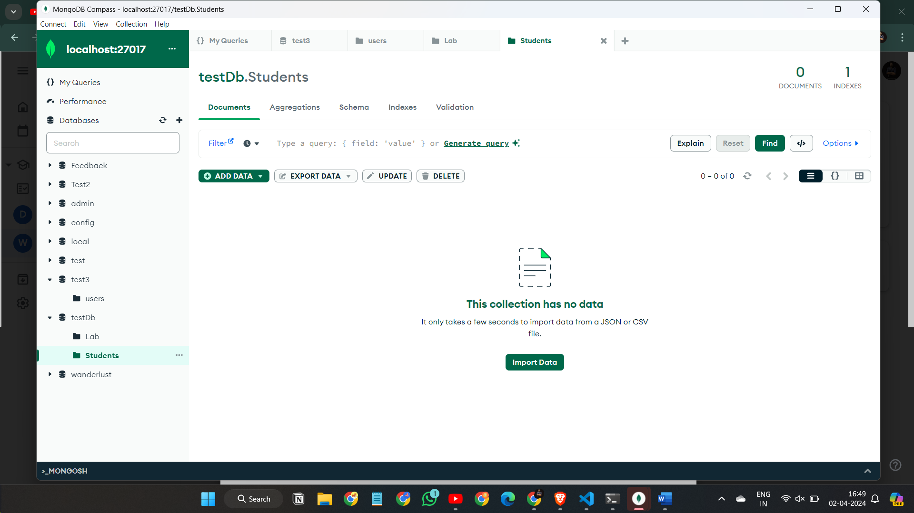

Step-3

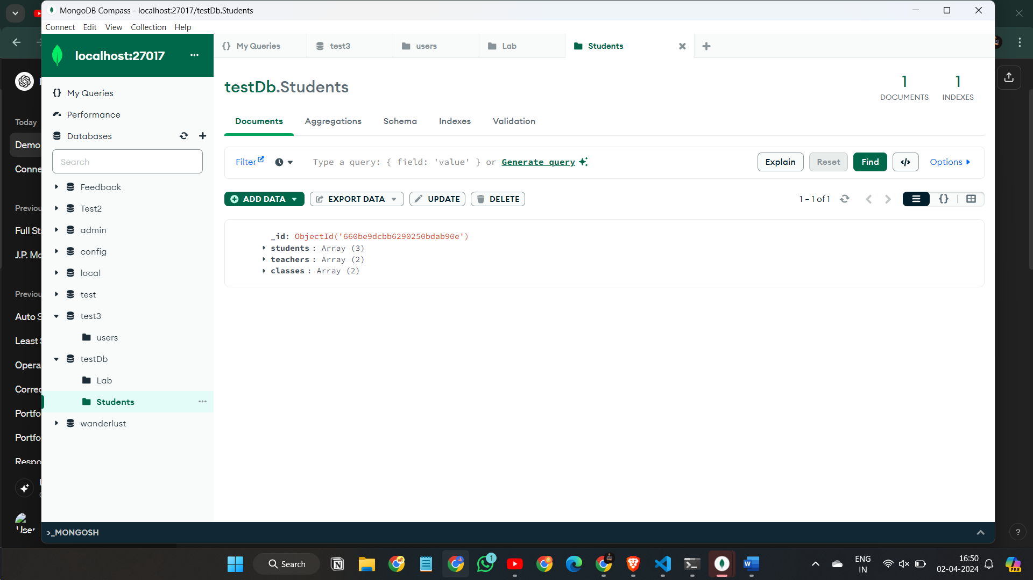

Q-4

Step-1

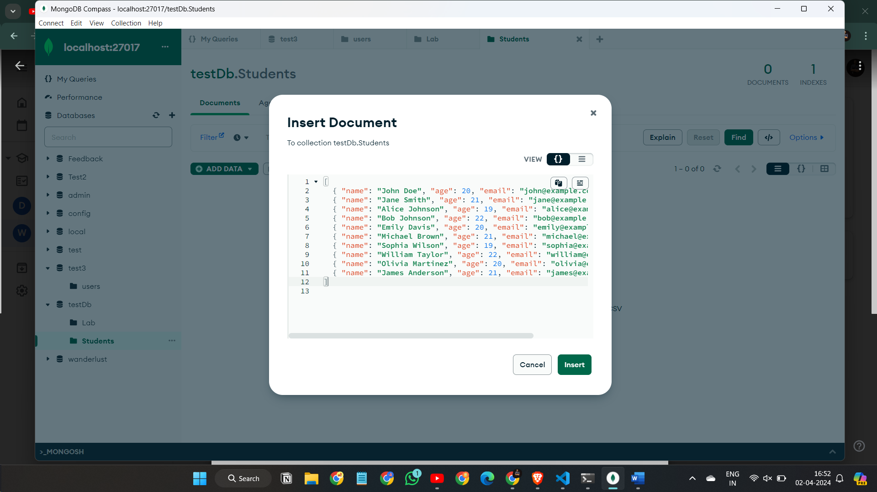

Q-5

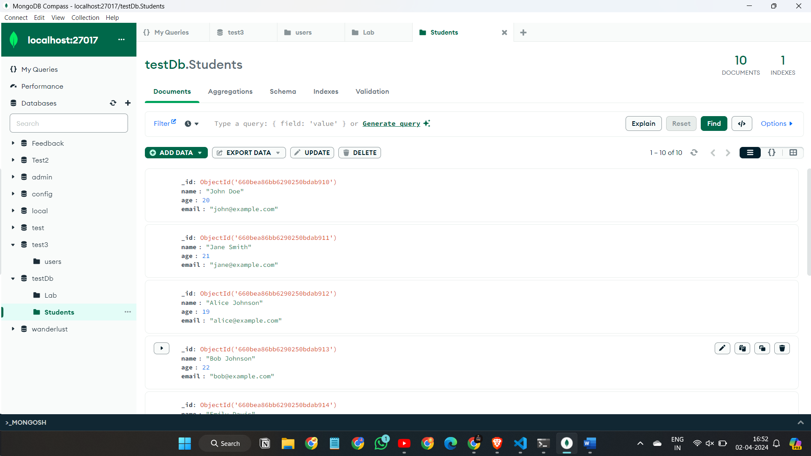

Q-6

Step-1

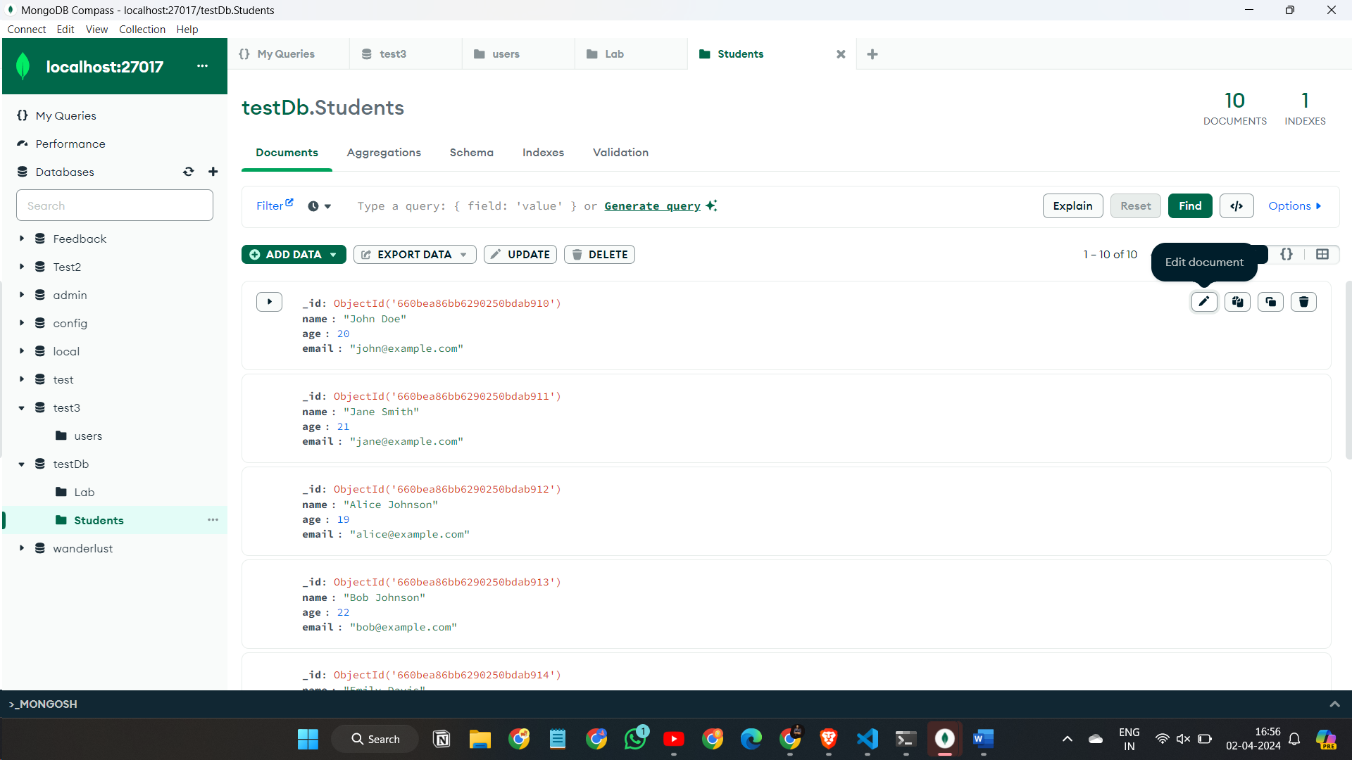

Step-2

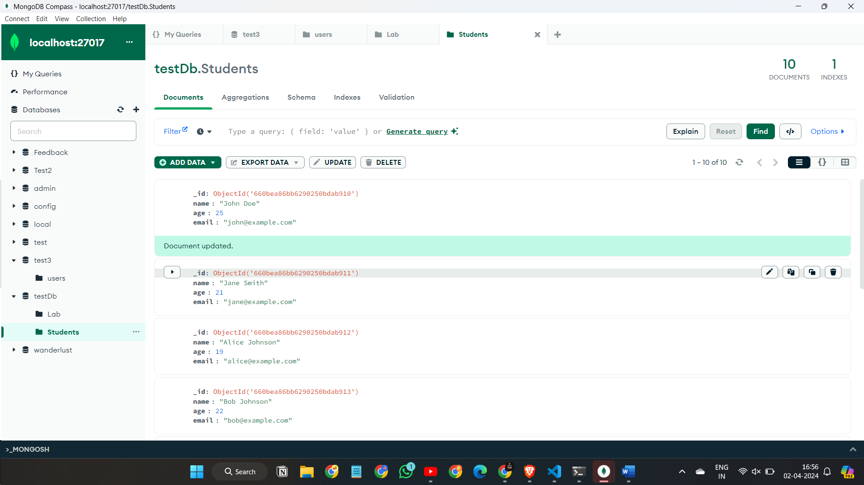

Q-7

Step-1

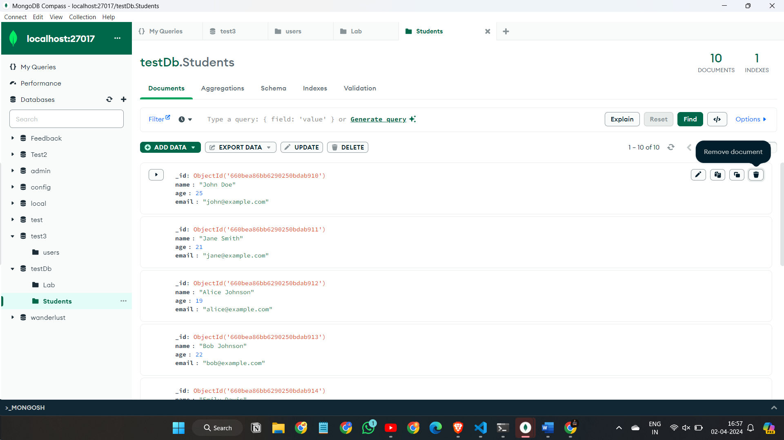

Step-2

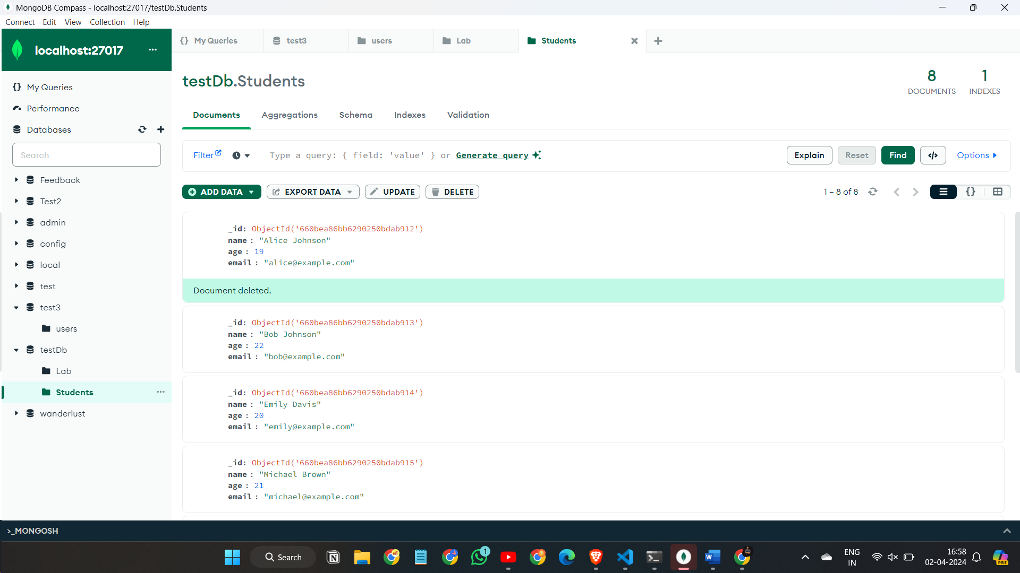

Q-8

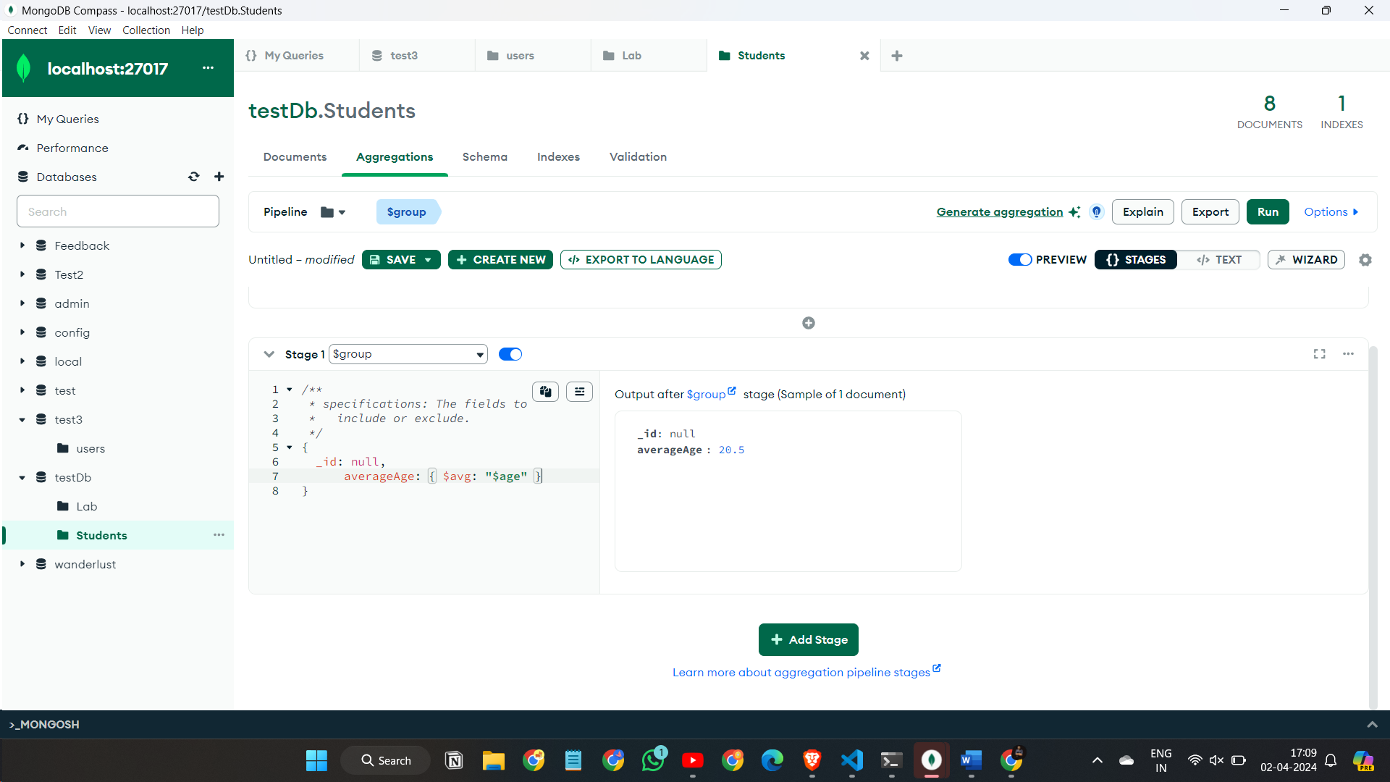

Q-9

Step-1

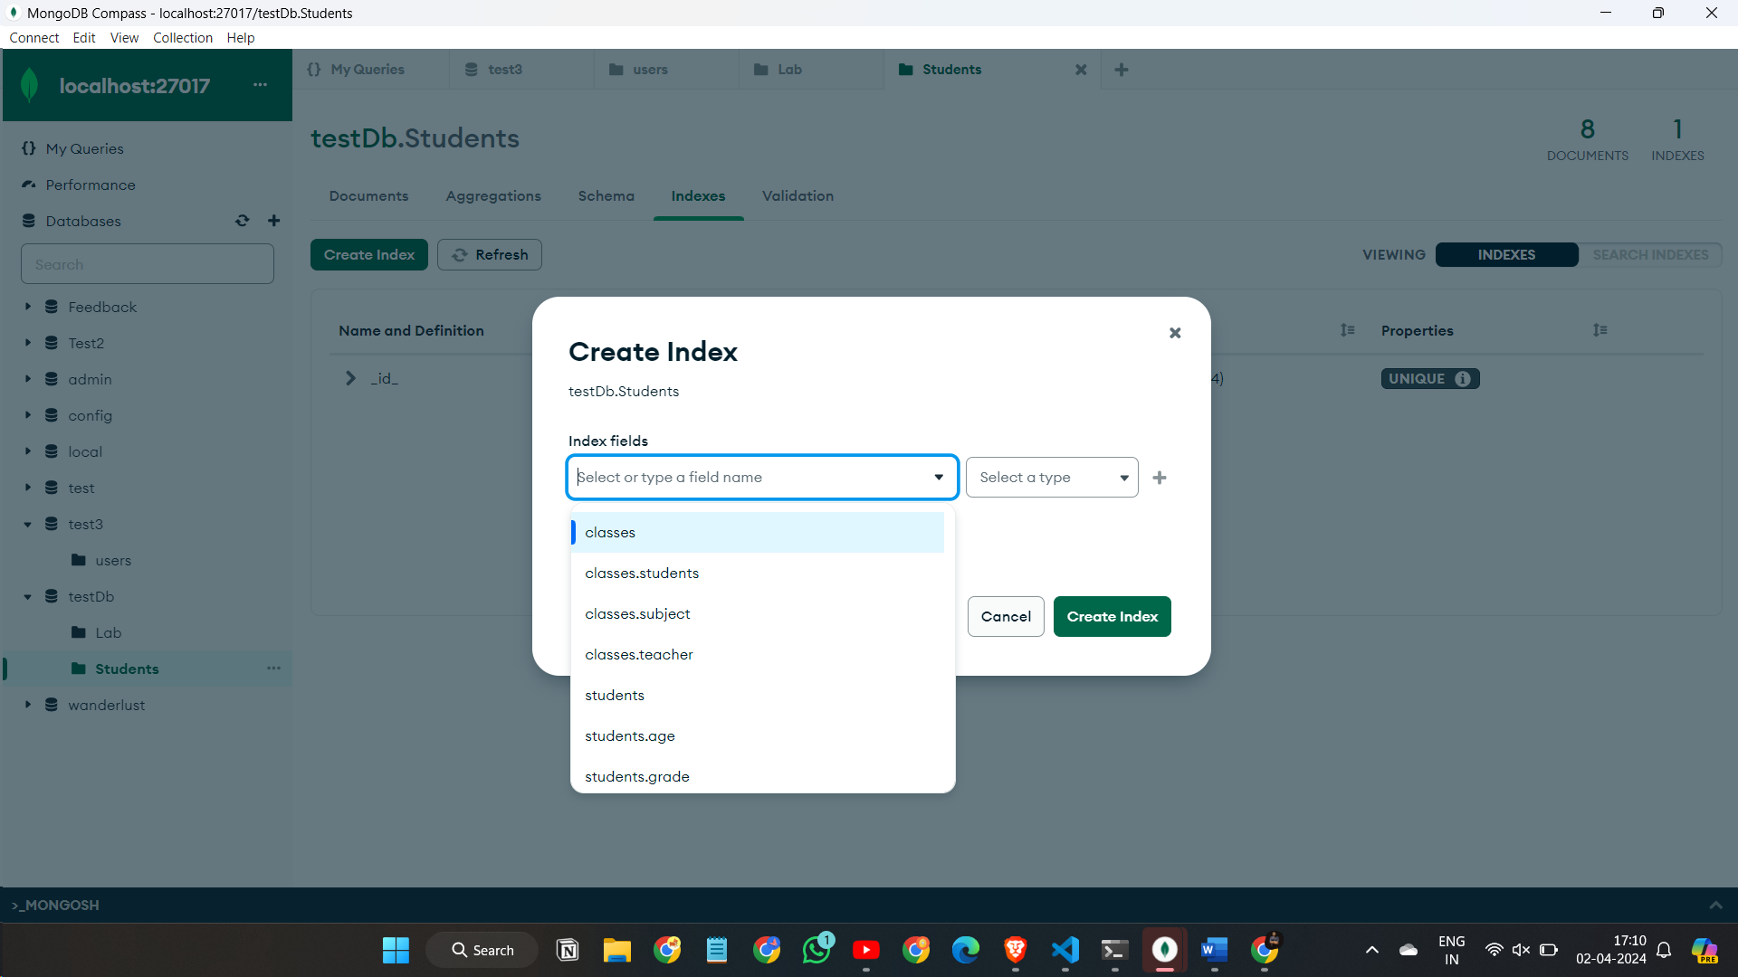

Step-2

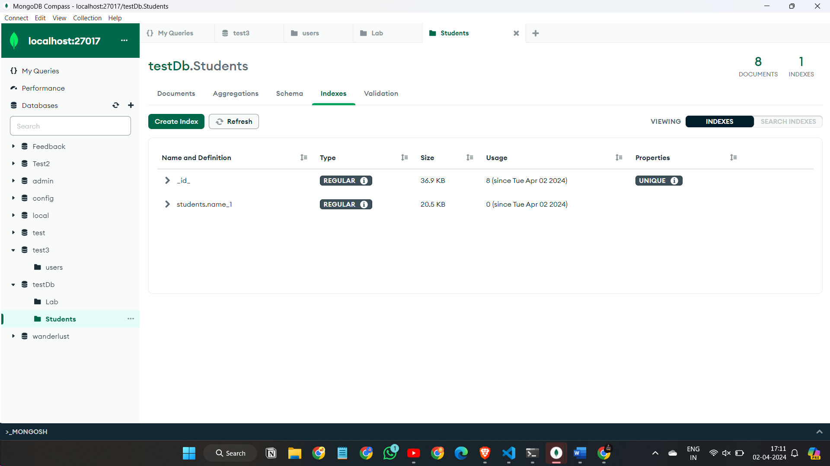

Q-10

Step-1

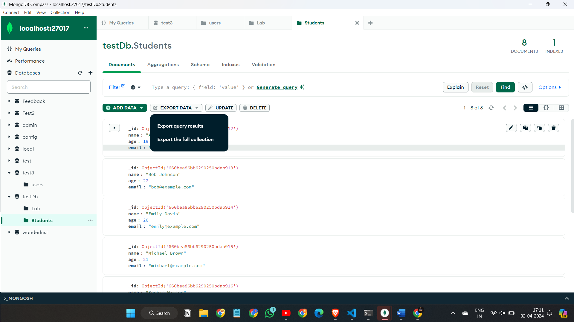

Step-2

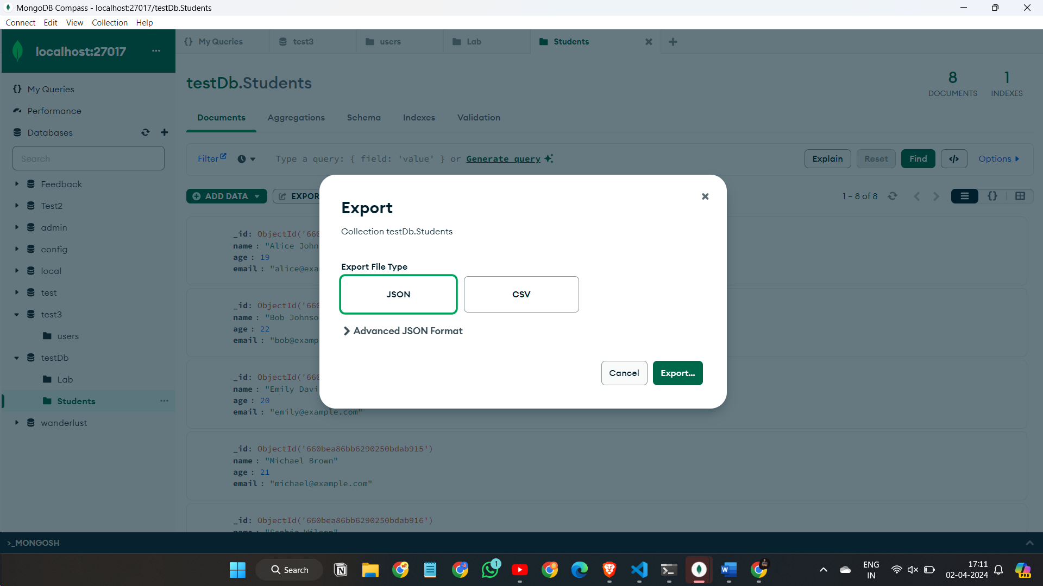

Step-3

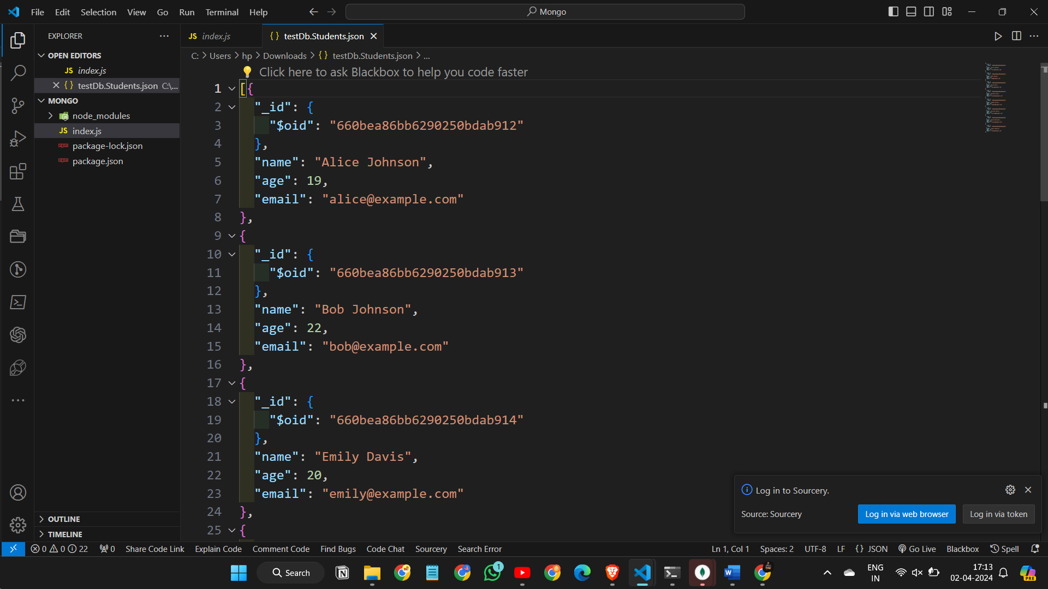

Q-13

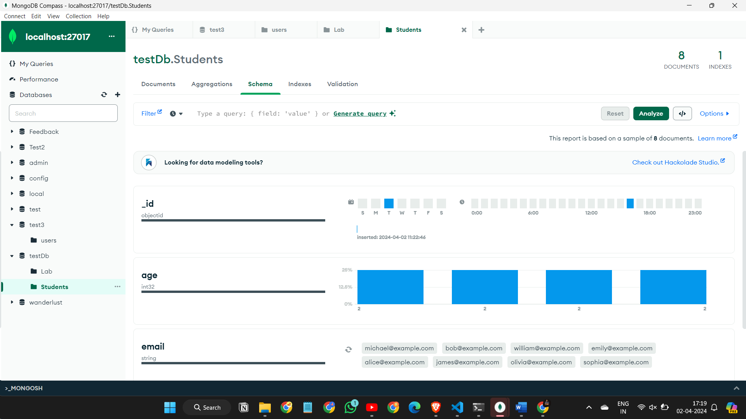

Q-14

